

Mini Project Report - 03

Master of Computer Application – General
Semester – III

Sub: Web Technologies

Topic: chess Board
By
Name: ADITH PRAKASH
Reg no.: 2511022250062

Faculty Name: VEERA RAGHAV K

Faculty Signature: _______________

Department of Computer Application
Alliance University
Chandapura - Anekal Main Road, Anekal
Bengaluru - 562 106

August 2025

INDEX

FIG NO | NAME OF TABLE | PG NO
1 | INTRODUCTION | 2
2 | INPUT CODE | 2-6
3 | OUTPUT CODE | 7
4 | CONCLUSION | 8

INTRODUCTION

The Chess Board Mini Project is developed using HTML and CSS to create a standard 8×8 chessboard pattern. HTML is used to structure the board using a table, while CSS is used to style the cells with alternating black and white colors. This project helps in understanding the basics of web development, including HTML tables, CSS classes, styling, and layout design. The main objective of this project is to demonstrate how simple web technologies can be used to create graphical patterns and user interfaces.

INPUT CODE

<!DOCTYPE html>
<html>
<head>
<title>Chess Board</title>
<style>
body{
display:flex;
justify-content:center;
align-items:center;
height:100vh;
background:#eee;
}

table{
border-collapse:collapse;
border:3px solid black;
}

td{
width:70px;
height:70px;
text-align:center;
font-size:45px;
}

.white{
background:#fafafa;
}

.black{
background:#f4ddaf;
}
</style>
</head>
<body>

<table>
<tr>
<td class="black">♜</td>
<td class="white">♞</td>
<td class="black">♝</td>
<td class="white">♛</td>
<td class="black">♚</td>
<td class="white">♝</td>
<td class="black">♞</td>
<td class="white">♜</td>
</tr>

<tr>
<td class="white">♟</td>
<td class="black">♟</td>
<td class="white">♟</td>
<td class="black">♟</td>
<td class="white">♟</td>
<td class="black">♟</td>
<td class="white">♟</td>
<td class="black">♟</td>
</tr>

<tr>
<td class="black"></td>
<td class="white"></td>
<td class="black"></td>
<td class="white"></td>
<td class="black"></td>
<td class="white"></td>
<td class="black"></td>
<td class="white"></td>
</tr>

<tr>
<td class="white"></td>
<td class="black"></td>
<td class="white"></td>
<td class="black"></td>
<td class="white"></td>
<td class="black"></td>
<td class="white"></td>
<td class="black"></td>
</tr>

<tr>
<td class="black"></td>
<td class="white"></td>
<td class="black"></td>
<td class="white"></td>
<td class="black"></td>
<td class="white"></td>
<td class="black"></td>
<td class="white"></td>
</tr>

<tr>
<td class="white"></td>
<td class="black"></td>
<td class="white"></td>
<td class="black"></td>
<td class="white"></td>
<td class="black"></td>
<td class="white"></td>
<td class="black"></td>
</tr>

<tr>
<td class="black">♙</td>
<td class="white">♙</td>
<td class="black">♙</td>
<td class="white">♙</td>
<td class="black">♙</td>
<td class="white">♙</td>
<td class="black">♙</td>
<td class="white">♙</td>
</tr>

<tr>
<td class="white">♖</td>
<td class="black">♘</td>
<td class="white">♗</td>
<td class="black">♕</td>
<td class="white">♔</td>
<td class="black">♗</td>
<td class="white">♘</td>
<td class="black">♖</td>
</tr>
</table>

</body>
</html>

OUTPUT CODE

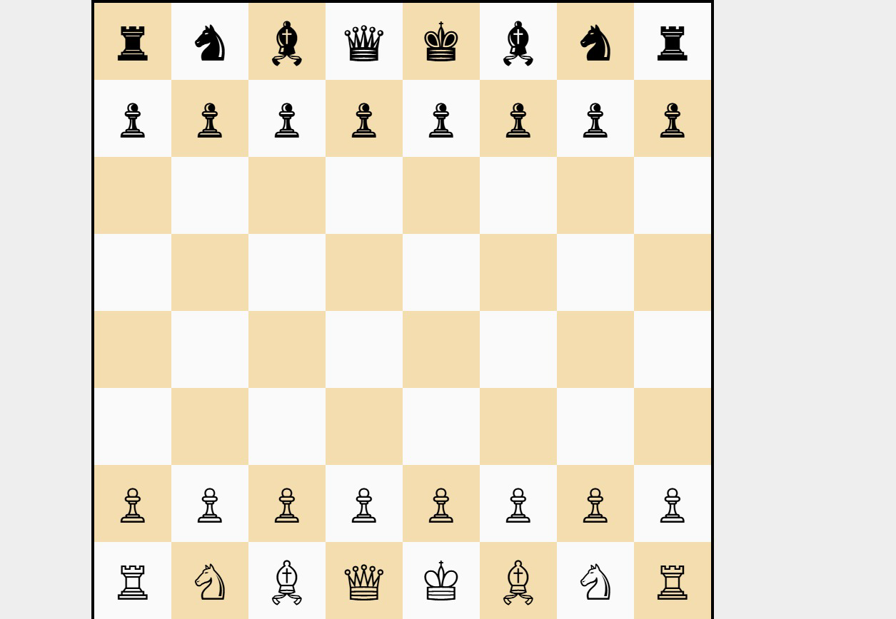

CONCLUSION

The Chess Board Mini Project successfully demonstrates the use of HTML and CSS to design a chessboard. By using table rows, table cells, and CSS styling, an 8×8 grid with alternating colors was created. This project enhanced our understanding of web page structure, styling techniques, and the practical application of HTML and CSS. It serves as a simple yet effective example of creating visual designs on a web page and forms a foundation for developing more advanced web applications.

